Add members to a Distribution List (DL) from a CSV file.

Hi There,

This script will help you to add members to a Distribution Lists (DL) from a CSV file

You just need a csv file with two columns: distribution list name (dlistname) and member (members)

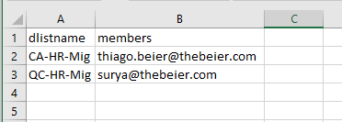

You can also combine this script with another one to add members to DL (Distribution Lists) as well.

**Testing the csv file:**

*Import-Csv .\create-dl.csv*

**You should see the following**

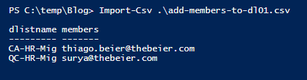

**PowerShell**

###########################################################################################

# Author Thiago Beier thiago.beier@gmail.com

# Version: 1.0 - 2020-FEB-28

# Adding user to a DL (Distribution List on Office 365) from CSV file

# Toronto,CANADA

# Email: thiago.beier@gmail.com

# https://www.linkedin.com/in/tbeier/

# https://thigobeier.wordpress.com

###########################################################################################

#

**Import-Csv** .\add-members-to-dl01.csv | **foreach** {

write-host "Adding user" $_.members "to" $_.dlistname "DL" -ForegroundColor Yellow

Add-DistributionGroupMember -Identity $_.dlistname -Member $_.members

}